**Q3 JENKINS DOCUMENT**

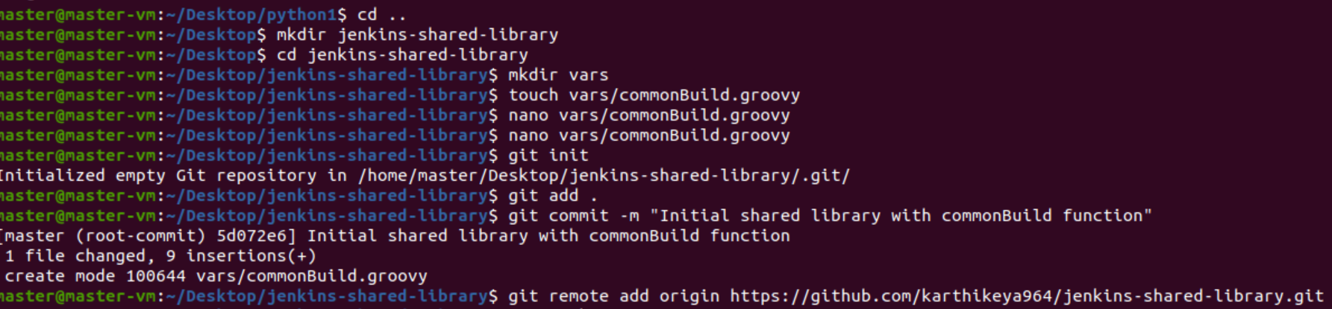

Common Build.groovy file:-



